**React HOL 3**

**React Components**

A React Component is a reusable piece of code that represents part of a user interface(UI). Think of it as a JavaScript function or class that returns JSX.

Components let you split the UI into independent, reusable pieces.

**Differences Between React Components and JavaScript Functions**

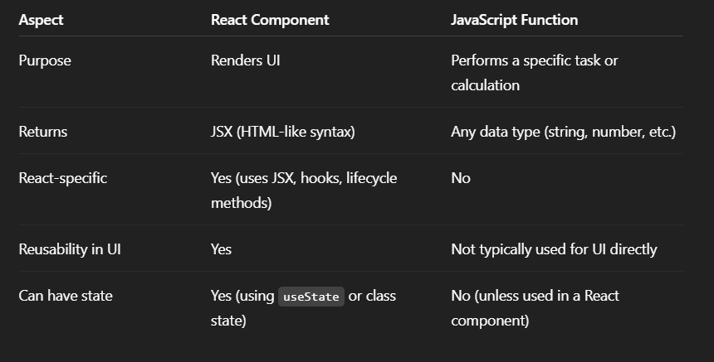

**Types of Components in React**

1. **Function Components**

Simple JavaScript functions that return JSX

1. **Class Components**

Use ES6 classes and extend React.Component

**Component Constructor**

The constructor method is used in class components to initialize the component’s state and bind methods.

**render() Function**

The render() method is required in class components and is used to return the JSX that should be displayed.

